1.

SELECT a.NAME as Student /* a.name을출력하며목록값에Student를준다. */

from student a LEFT OUTER JOIN TAKES b /* student를a라는변수로저장, TAKES를b라는변수로저장하며LEFT OUTER JOIN를한다*/

/* JOIN할테이블중왼쪽에값이없는것포함하여출력. 일치하지않아도NULL값으로출력된다. */

on a.ID = b.ID /* 조건Student의id와TAKES의id를같은것을찾는다.*/

orderbyStudent/*정렬을시킨다.기본적으로오름차순.*/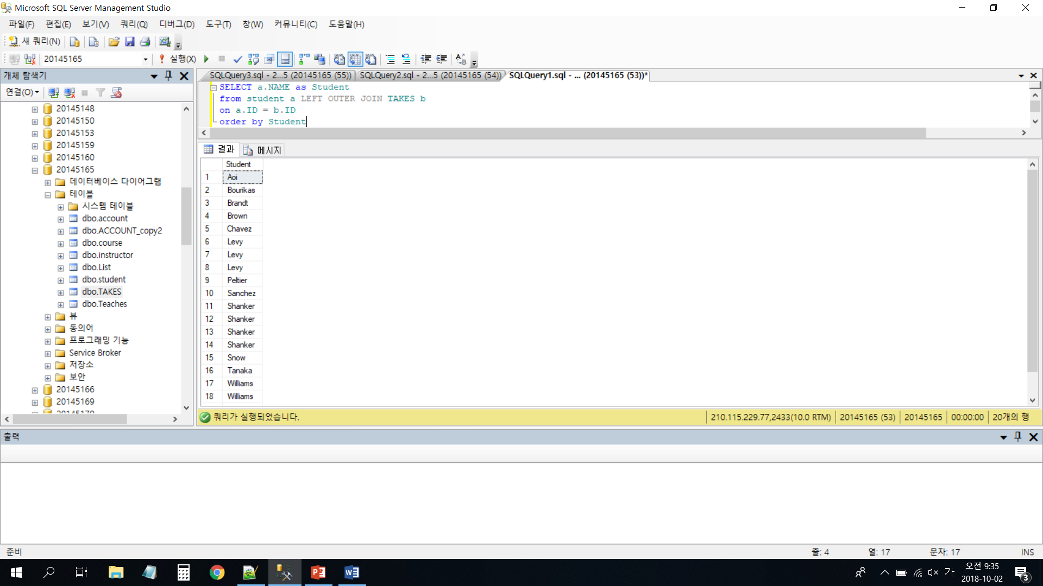

2.

select semester /* 찾을값*/

from Teaches /* 찾는곳*/

where course_id LIKE'C%' and years = 2009 /* 조건c로시작하며2009년인계절*/

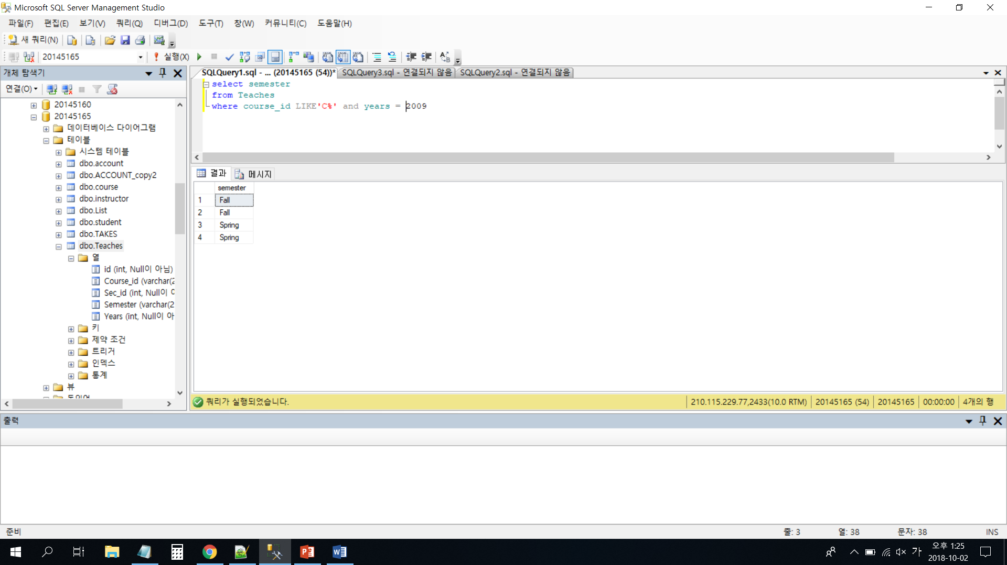

3.

IF (select AVG(salary) from instructor) >= 70000 /* salary의평균이70000만이상인가? */

BEGIN /* 그렇다면*/

select name,dept_name /* 출력한다name과dept_name */

from instructor /* instructor의있는*/

END /* 끝! */

ELSE /* 조건에충족하지않는다면*/

PRINT '연봉이70000이상인교수가없습니다.' /* print을한다. */

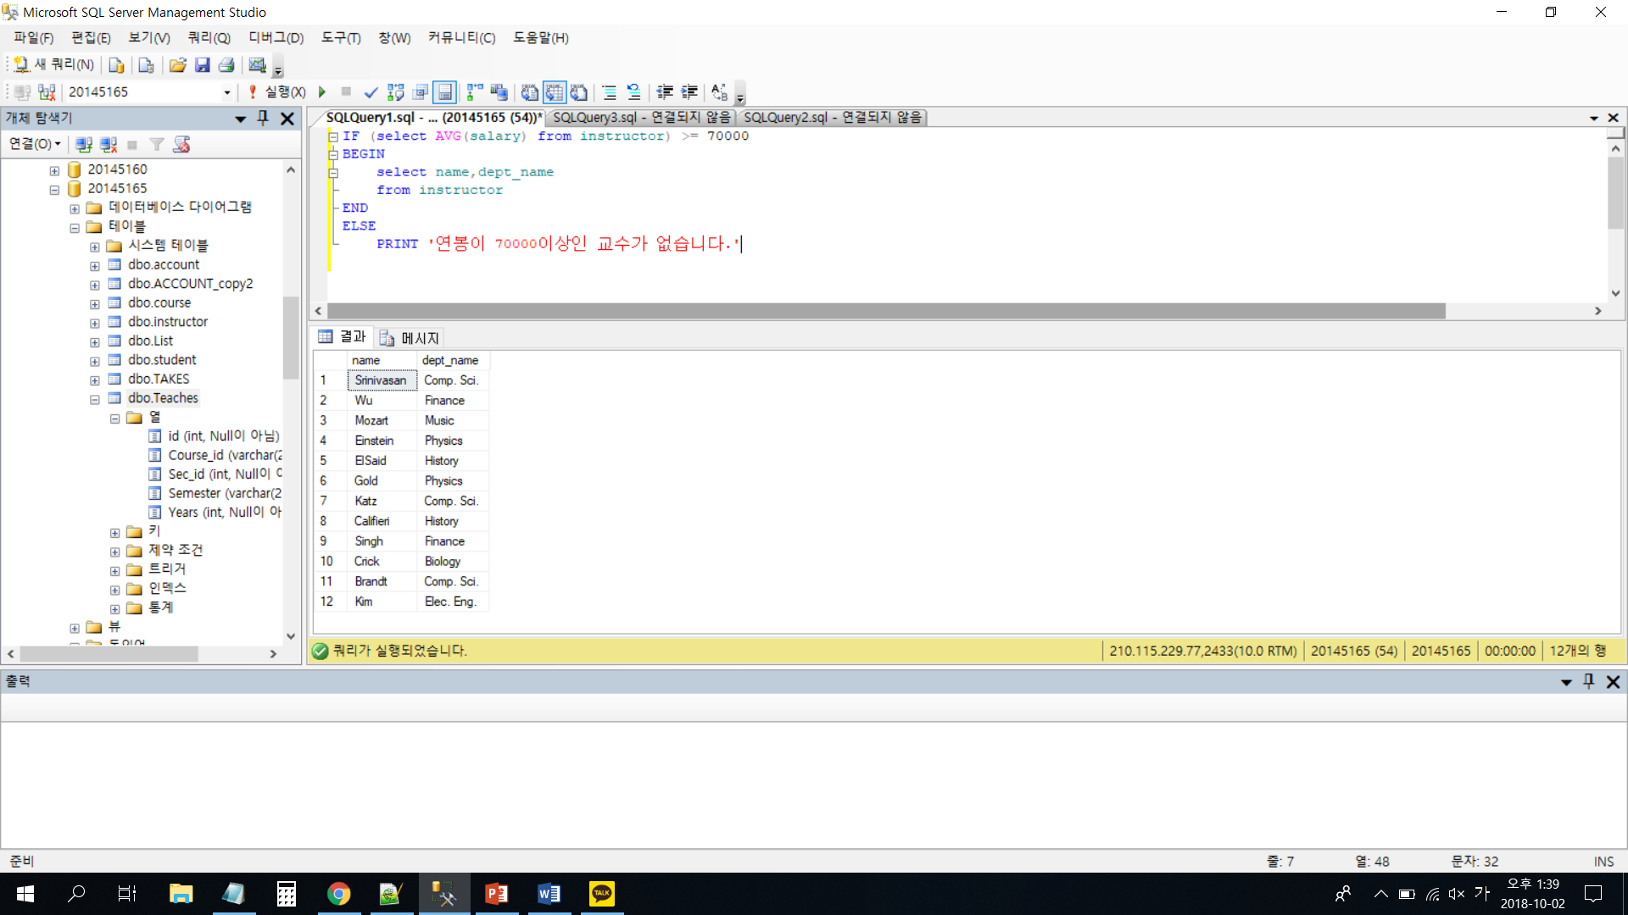

4.

SELECT salary,

CASE WHEN salary >= 60000 /* 조건에따라다른값입력하기, salary가60000 이상이면*/

THEN salary * 1.03 /* salary의1.03을곱하며*/

ELSE salary * 1.05 /* 아니면1.05을곱한다*/

END new_salary /* 결과는new_salary에출력*/

FROM instructor

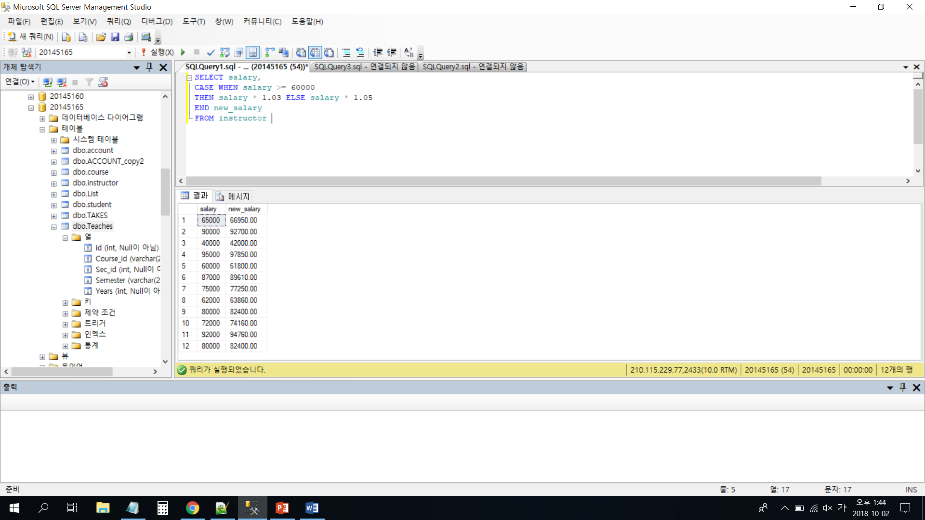

실습 과정

Join

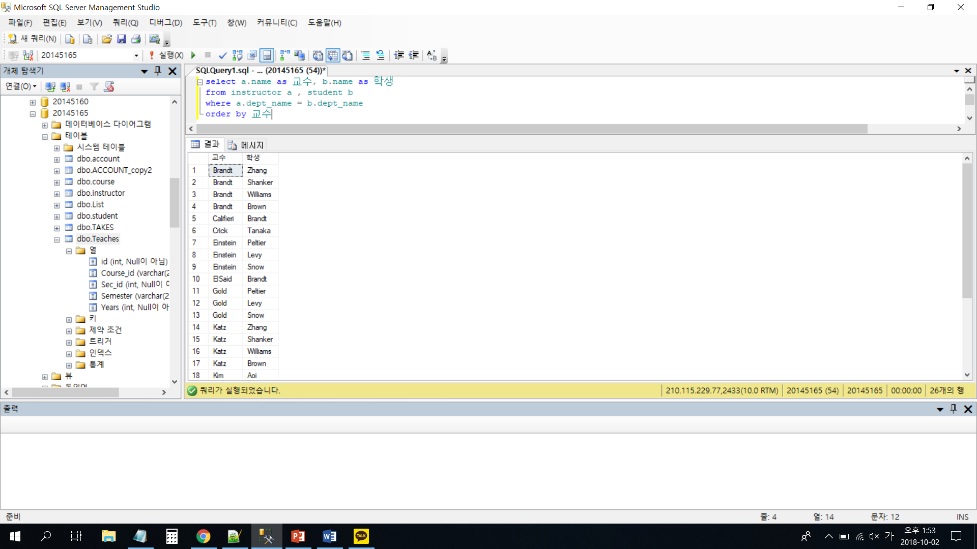

Inner join

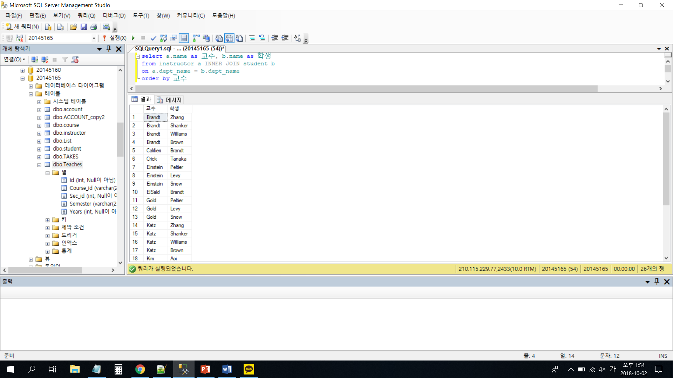

LEFT JOIN

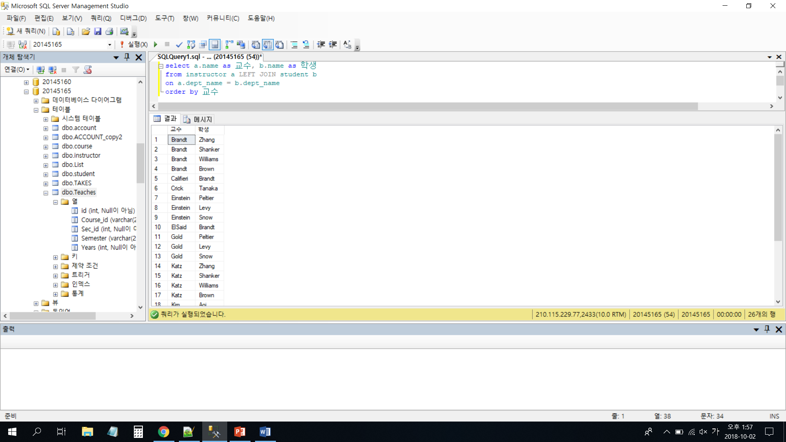

RIGHT OUTER JOIN

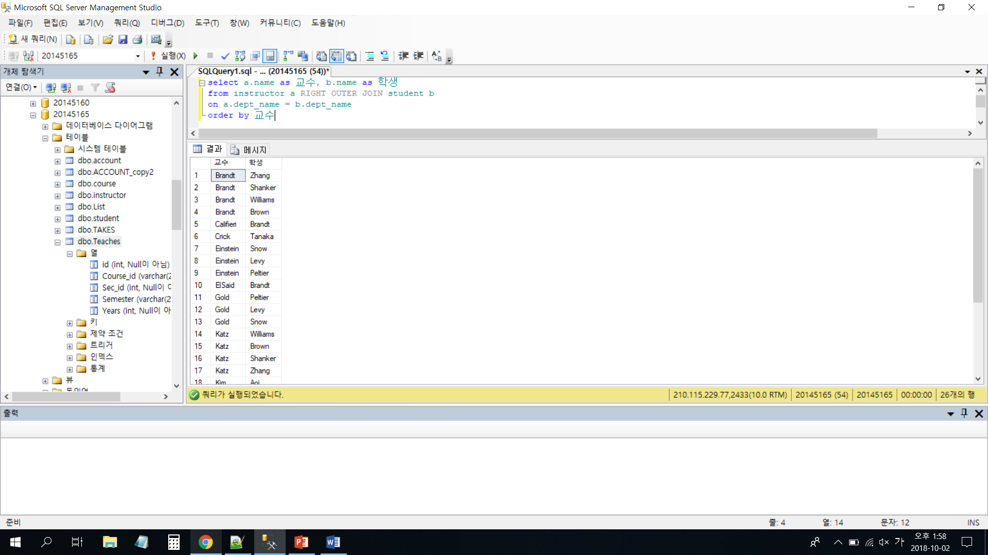

RIGHT JOIN

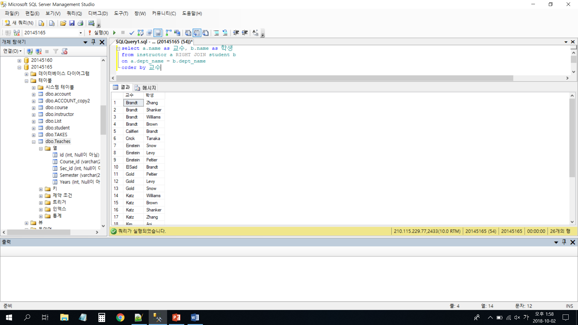

union

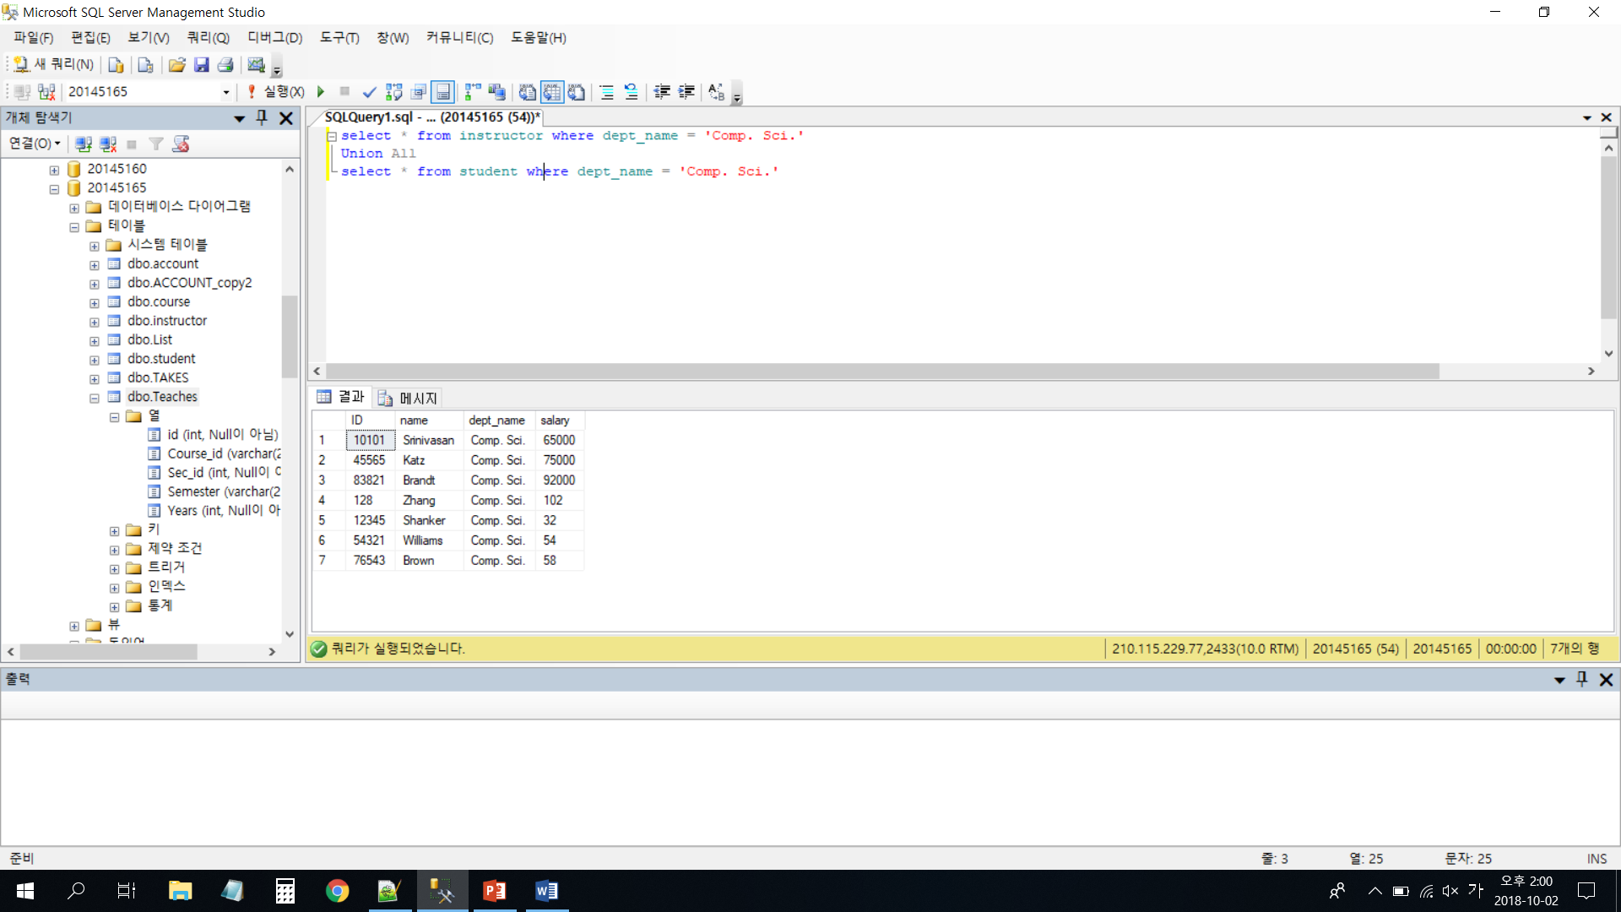

Subquery

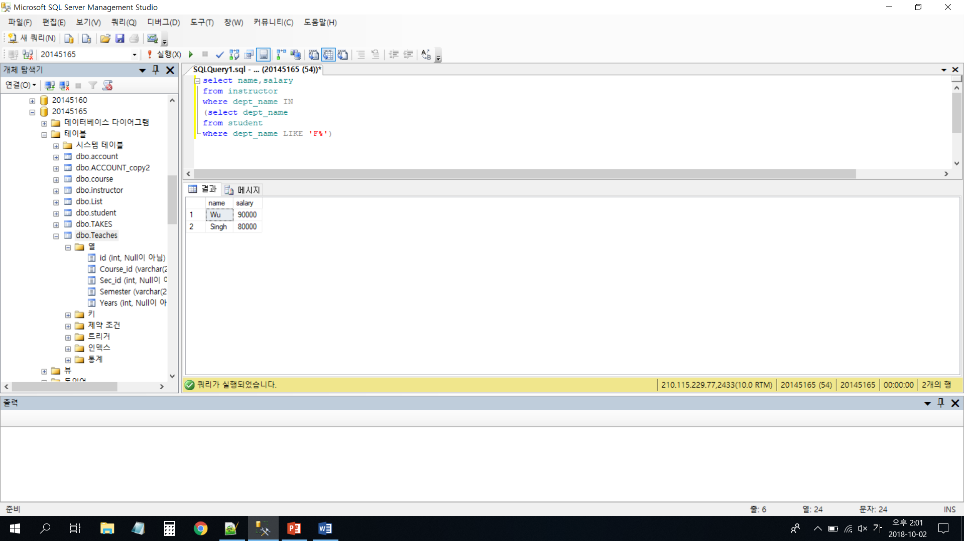

EXISTS

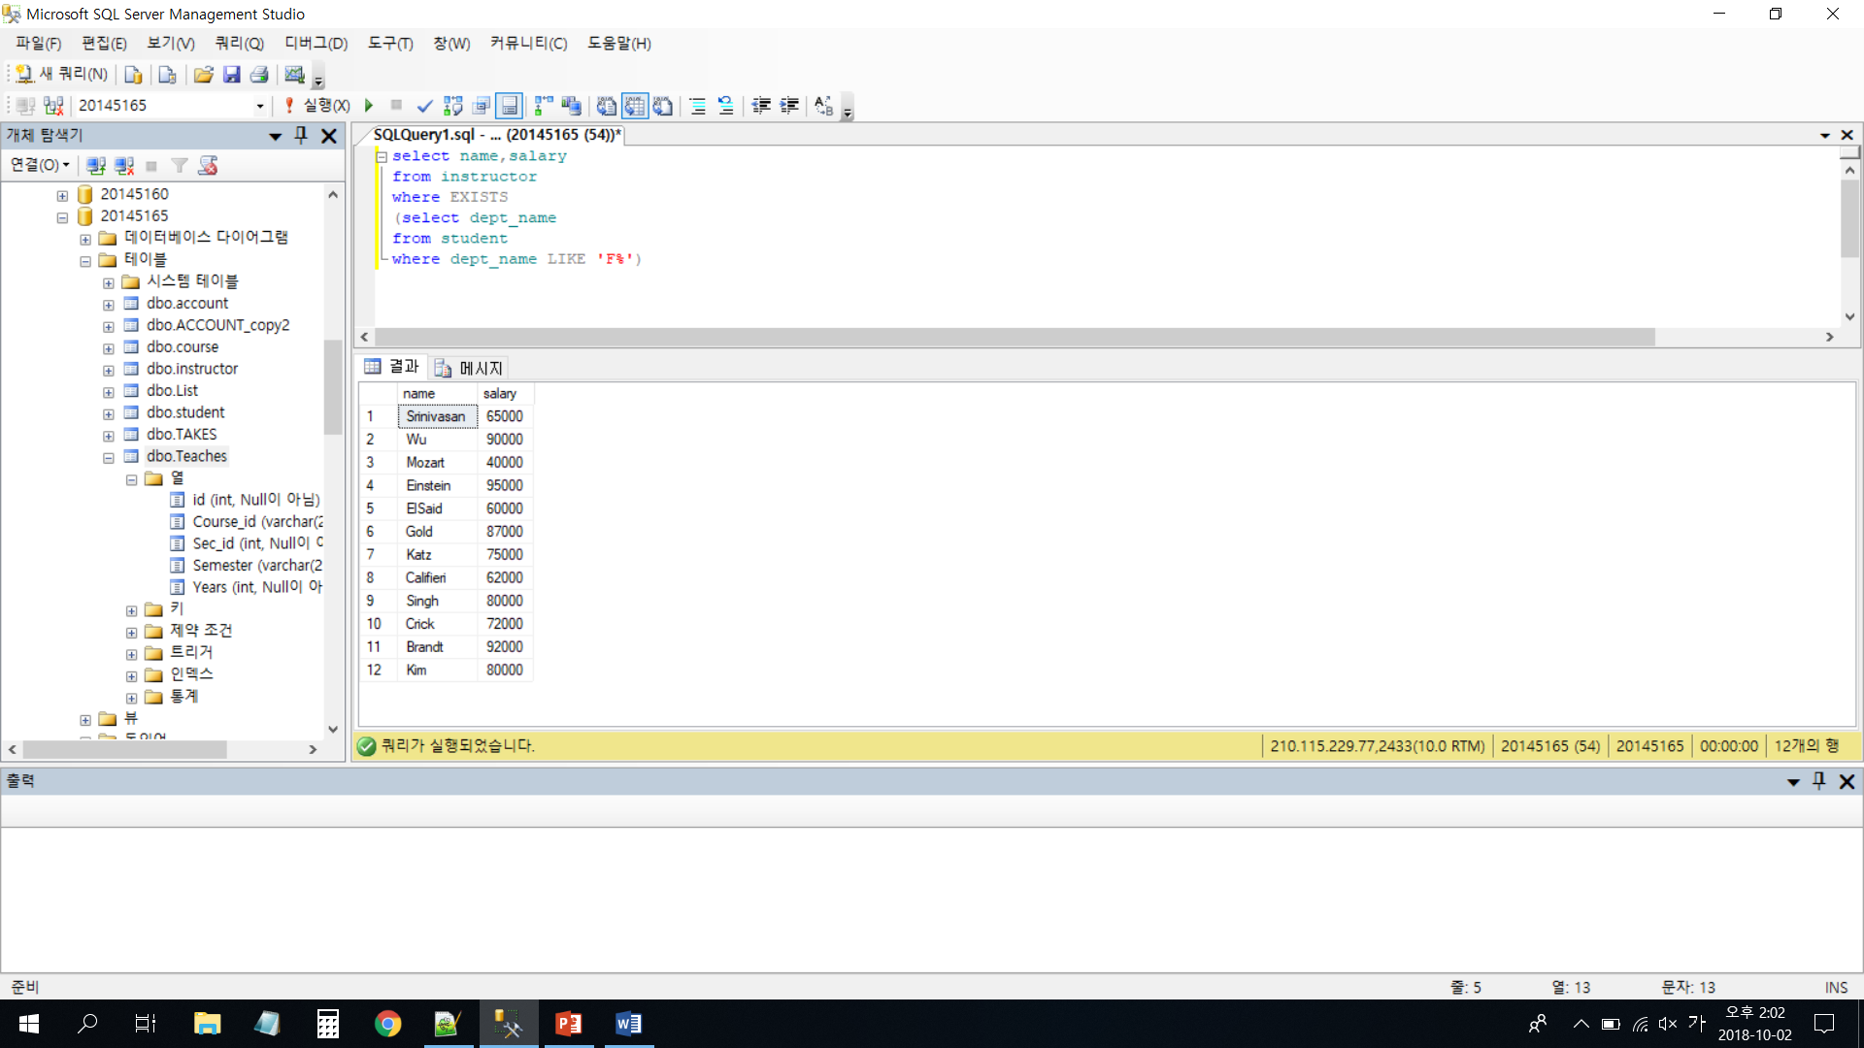

CASE

